First Quarter

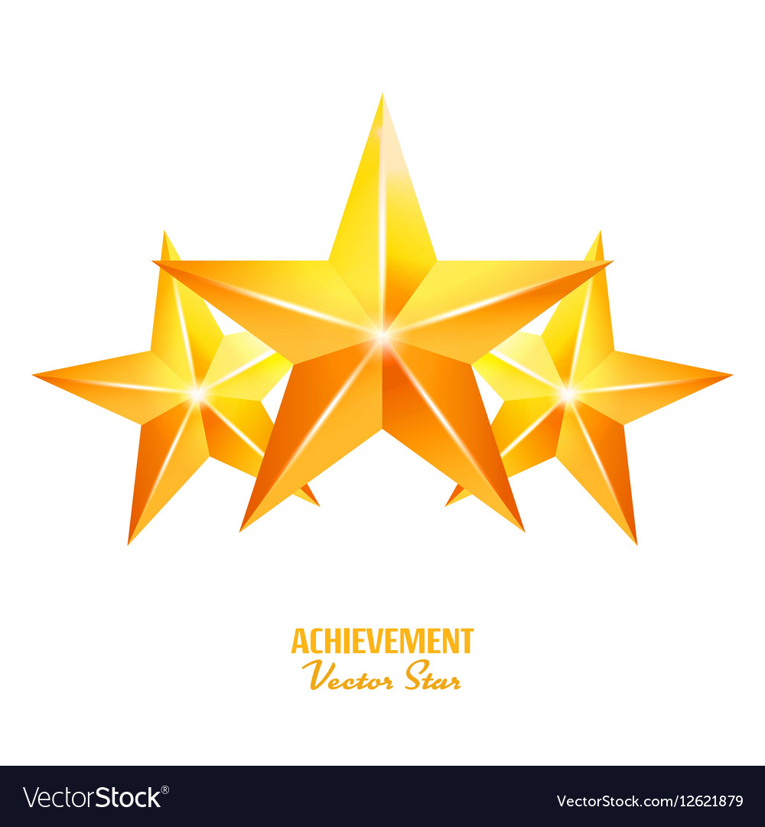Honor Roll

6th Grade

Amari Akin David Bell

Jayden Collins Kiara Dorce

Cing Hoih Ridlaan Ibrahim

Namaht Imzilane Milat Kesete

Cole Knight Christopher Lara-Armenta

Fatuma Luundo Kelsey Maldonado Maldonado

Elijah McCreary-Parks Karen Mendez Rodriguez

Honorine Mucyowera Melvine Ogweno

Moline Ogweno Kimberly Ramos

Farhia Shire Ethan Tabor

Anna Tisiya Samuel Vang

Rabliv Chyruz Vilbar Tiara Walls

Brian Young Anna Zawadi